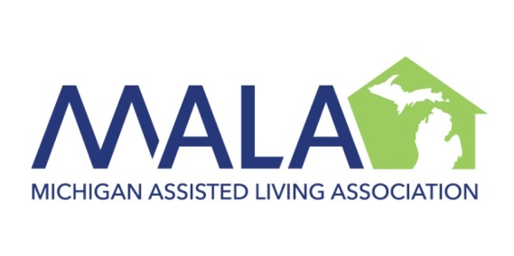

HONOR YOUR EMPLOYEES TODAY
for the
2019 SPIRIT OF SERVICE AWARDS

January, 2019

Dear Member:

Michigan Assisted Living Association and BATOR LOBB are looking forward to the 2019 Spirit of Service Awards. This annual awards program is an excellent opportunity to honor supervisory staff providing services to persons with disabilities and older adults.

Click here for a description of the Spirit of Service Awards program and nomination form. You are encouraged to complete the nomination form as soon as possible. The nomination deadline is April 19, 2019.

The three award winners will be honored for their outstanding accomplishments during the luncheon presentation at the MALA Annual Conference. The event will be held at the Lansing Center on May 14, 2019.

We hope that you will participate in the awards program and look forward to seeing you at the MALA Annual Conference.

Sincerely,
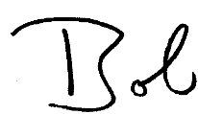  ROBERT L. STEIN  General Counsel | 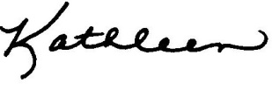  KATHLEEN M. MURPHY  General Counsel

cc: Gregory Bator, BATOR LOBB

Note: In submitting nominations, please feel free to include individuals previously nominated who did not receive a Spirit of Service Award. We recognize that there are many prior outstanding nominees who have not been awardees.

Call for Nominations!

SPIRIT OF SERVICE AWARDS

Who? Providers who wish to recognize deserving supervisory staff whose outstanding achievements enhance the lives of people they serve.

What? Nominate up to two (2) individuals!
• All nominees will receive a Certificate of Achievement and be recognized.

When? Tuesday, May 14, 2019
• Please submit nominations no later than April 19, 2019.

Where? The Spirit of Service luncheon and presentation at the MALA Annual
Conference.

Why? The law firm of BATOR LOBB proudly joins with MALA in recognizing special achievements in assisted living, residential and vocational services.

How? Nominate up to two (2) supervisory staff for recognition by completing a nomination form for each nominee.
• Include specific information that demonstrates the strongest reasons why
your nominees should win the award. You may include as much information from yourself and others about the nominee.
• Provide specific examples of excellence in providing services.
• Nominations are NOT restricted to the nomination forms.

Proud Sponsors of SOS Awards
BATOR LOBB serves the complete business and personal legal needs of providers. It prides itself on offering economically priced and efficient legal services to clients throughout the State of Michigan.

Michigan Assisted Living Association (MALA) is a strong advocate for high quality services for persons with disabilities and older adults. We appreciate the thousands of dedicated providers and support staff providing services throughout our state.

Nomination Deadline
April 19

NOMINATION FORM
SPIRIT OF SERVICE AWARDS

Name of Nominee:
Your Name (Nominator):
Your Company:
Your Address:
Business Phone: Business Fax:
Your E-Mail Address:

Please describe your reasons why the Nominee exemplifies the Spirit of Service. Provide as much information as you would like.. The person nominated for the Spirit of Service Award can be any individual within or outside of your organization. Past winners benefited from specific examples of excellence in providing services. Thank you for your participation in bringing honor to this distinguished individual. Use additional sheets of information if
necessary.

Mail, Fax, or Email Nominations to:
Gregory Bator
BATOR LOBB, P.C.
4 Parklane Blvd., Suite 310
Dearborn, MI 48126
Fax (248) 642-5922
gregory@batorlobb.com

PLEASE CONTINUE WITH INFORMATION CONCERNING YOUR NOMINEE:

Mail, Fax, or Email Nominations to:
Gregory Bator
BATOR LOBB, P.C.
4 Parklane Blvd., Suite 310
Dearborn, MI 48126
Fax (248) 642-5922
gregory@batorlobb.com

The Selection Process

1. All nominations must be received by April 19, 2019.

2. A panel of judges knowledgeable of assisted living, residential and vocational services will evaluate the nominees and all additional material submitted.

3. Winners will be selected on the basis of their service to the persons they serve. Past winners benefited from specific examples of the nominee’s skills, accomplishments, and personal attributes. Use additional sheets as needed. Supportive letters are beneficial.

4. Winners will be notified by April 26, 2019. All winners will be encouraged to attend the
MALA Annual Conference in Lansing to receive their award on May 14, 2019.

5. Nominees for all awards will receive a Certificate of Achievement to commemorate their noted accomplishments.

Together, We Serve the Special Needs of Providers

